AI Citation Gap Report Sample
Why FreyaVideo Is Missing From “Product Photo to Video” AI Recommendations
Prepared as a sample report for validating the “AI Citation Gap Report” service concept

Product | FreyaVideo
Website | https://freyavideo.com
Category | AI product video / ecommerce video ads / product photo to video
Report type | AI Citation Gap Sample Report
Test date | 2026-05-29
Engines tested | ChatGPT, Perplexity
Prompts tested | 7 buyer-style prompts

Important note
This is a sample report based on FreyaVideo, one of my own projects. It is designed to demonstrate the type of evidence, diagnosis, and action plan a paid AI Citation Gap Report would deliver for indie SaaS and AI tool founders.

Contents
- 1. Executive Summary
- 2. What This Report Measures
- 3. Prompt Results Overview
- 4. ChatGPT Findings
- 5. Perplexity Findings
- 6. Competitor Citation Pattern
- 7. Why FreyaVideo Is Likely Missing
- 8. What FreyaVideo Should Not Do
- 9. Recommended Fix Plan
- 10. Suggested Page Outline
- 11. Final Diagnosis
- 12. What This Sample Report Demonstrates
- Appendix: Evidence Screenshots

1. Executive Summary
FreyaVideo was not mentioned in the tested ChatGPT and Perplexity buyer-style prompts.
This matters because several prompts were highly relevant to FreyaVideo’s current product direction, especially: “Best AI product video generator from photos.”
Both ChatGPT and Perplexity understood the category and recommended multiple product-photo-to-video, ecommerce ad video, and AI video tools. However, FreyaVideo did not appear in the answer set.
This suggests that FreyaVideo may have a citation and category-association gap.
The issue is not simply that the prompts were wrong. The AI systems returned relevant competitors and adjacent tools, but FreyaVideo was not recognized as part of the category.
Main opportunity
The strongest opportunity is to reinforce one narrow positioning:

Turn product photos into ecommerce ad videos — pay per use, no monthly subscription.

2. What This Report Measures
This report checks whether FreyaVideo appears when potential buyers ask AI search tools questions such as:
- best AI product video generator from photos
- best AI video generator for ecommerce ads
- best AI video ad generator for Shopify products
- best AI UGC ad video generator
- affordable AI video generator for small businesses
The goal is not to claim a fixed “AI ranking.” AI answers can change based on model version, time, location, source availability, account state, and prompt wording.
This report is a structured sample designed to identify:
- Whether FreyaVideo appears in buyer-style AI recommendations.
- Which competitors appear instead.
- How those competitors are positioned.
- What citation or content gaps may explain the difference.
- What FreyaVideo should fix first.

3. Prompt Results Overview
# | Prompt | Engine | FreyaVideo Mentioned? | Main Tools Recommended
1 | Best AI video generator for ecommerce ads | ChatGPT | No | AdCreate, Advivi, CreateUGC, Blubo AI, VidAU, URLToVideo
2 | Best AI video ad generator for Shopify products | ChatGPT | No | Videna, Veymo, Shhots AI, Adify, MotionDrop, Advivi, CreateUGC
3 | Best AI UGC ad video generator | ChatGPT | No | Arcads, MakeUGC, Creatify, HeyGen, AdMakeAI, Magic Hour, InVideo, VEED, Pictory
4 | Best AI product video generator from photos | ChatGPT | No | Movo AI, Media.io, Mokzu AI, Clipfly, Vimer AI, VENE.AI, InVideo, HeyGen
5 | Affordable AI video generator for small businesses | ChatGPT | No | Canva, CapCut, Creatify, HeyGen, Synthesia, InVideo, Runway, Pika
6 | Best AI product video generator from photos | Perplexity | No | RAWSHOT AI, Photoroom, Luma AI, Runway, Shhots AI, Hailou AI
7 | Best AI video generator for ecommerce ads | Perplexity | No | Creatify, Zeely, InVideo, Luma AI, Shhots AI

4. ChatGPT Findings

4.1 Ecommerce Ads Prompt
Prompt tested: “Best AI video generator for ecommerce ads. Please compare the top tools in English.”
Tools recommended by ChatGPT: AdCreate, Advivi, CreateUGC, Blubo AI, VidAU, URLToVideo.
Observation: ChatGPT treated this as an ecommerce ad production workflow, not a generic AI video generation workflow. The recommended tools were positioned around product URL to video, product page to ad, UGC-style ad creative, ecommerce templates, bulk video output, and paid social ad variations.
Interpretation: FreyaVideo is not currently being associated by ChatGPT with the “ecommerce ad generator” category, even though its product direction overlaps with product images and ecommerce video ads.

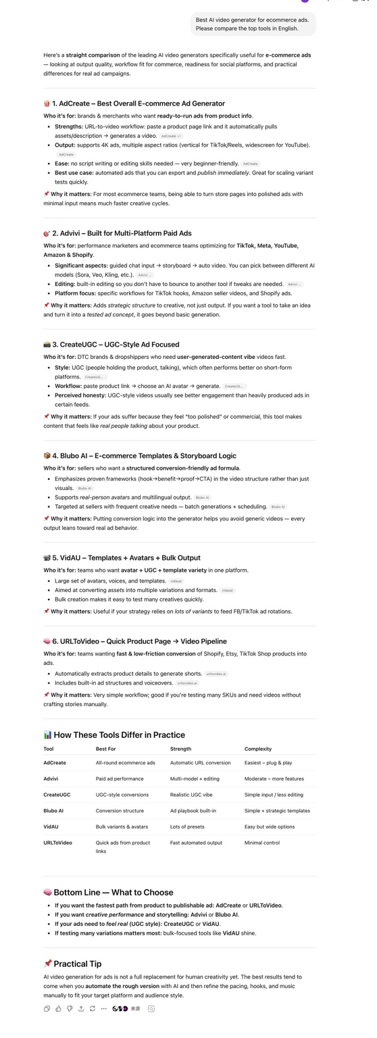
Figure 1. ChatGPT result for “Best AI video generator for ecommerce ads.”

4.2 Shopify Product Ads Prompt
Prompt tested: “I’m looking for the best AI video ad generator for Shopify products. Which tools should I consider, and why?”
Tools recommended by ChatGPT: Videna, Veymo, Shhots AI, Adify, MotionDrop, Advivi, CreateUGC / Tagshop AI.
Observation: ChatGPT favored Shopify-native or Shopify-adjacent workflows: Shopify app integration, product metadata import, product catalog to video, SKU-level video generation, and product URL to ad video.
Interpretation: This prompt reveals a positioning boundary. FreyaVideo should not over-claim “Shopify-native video automation” unless it actually supports Shopify store import, product feed import, or Shopify metadata workflows.

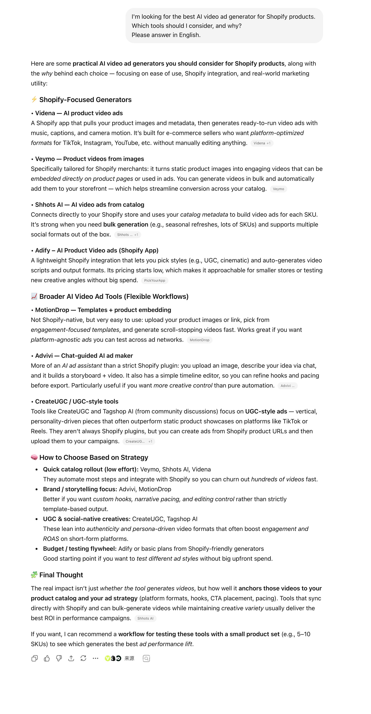
Figure 2. ChatGPT result for “AI video ad generator for Shopify products.”

4.3 UGC Ad Video Prompt
Prompt tested: “I’m looking for the best AI UGC ad video generator. Which tools should I consider, and why?”
Tools recommended by ChatGPT: Arcads, MakeUGC, Creatify, HeyGen, AdMakeAI, Magic Hour, InVideo, VEED, Pictory.
Observation: ChatGPT understood “UGC ad video generator” as a creator-style, avatar, talking-head, and performance ad workflow. The recommended tools were associated with human-like delivery, avatar presenters, talking-head clips, persona-driven ads, high-volume ad testing, and UGC-style hooks and scripts.
Interpretation: This is not necessarily a bad result. It suggests that “UGC ad generator” may not be FreyaVideo’s best category unless the product supports avatar, creator-style, or talking-head ad videos.

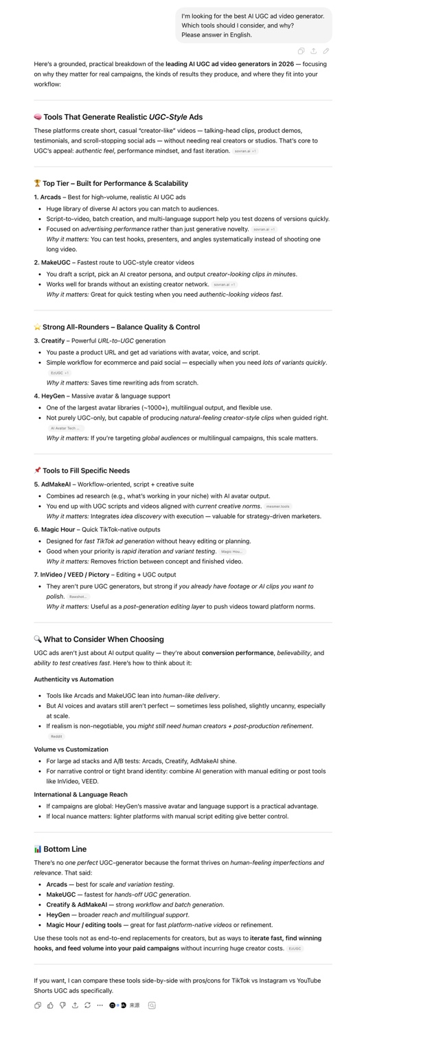
Figure 3. ChatGPT result for “best AI UGC ad video generator.”

4.4 Product Video From Photos Prompt
Prompt tested: “Best AI product video generator from photos. Please compare the top tools in English.”
Tools recommended by ChatGPT: Movo AI, Media.io AI Product Video Generator, Mokzu AI, Clipfly, Vimer AI, VENE.AI, Morph Studio, VidMix.ai, Shotra, InVideo AI, HeyGen.
Observation: This is the strongest missing signal. The prompt directly matches FreyaVideo’s relevant category: turning product photos into videos. ChatGPT recommended product-photo-to-video and ecommerce-ready video tools, but FreyaVideo was not included.
Interpretation: This suggests that the issue is not only prompt mismatch. FreyaVideo may have relevant product capabilities and on-site pages, but ChatGPT does not yet strongly associate the brand with product photo to video, ecommerce product video generator, product image to video ads, or AI product showcase videos.

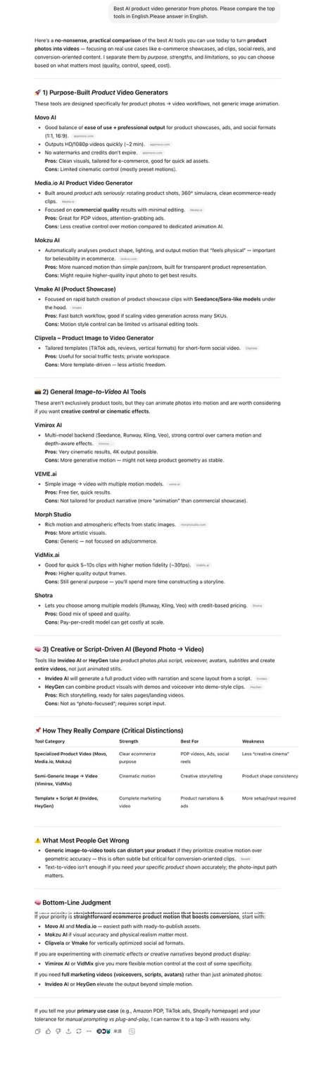
Figure 4. ChatGPT result for “Best AI product video generator from photos.”

4.5 Affordable AI Video Generator Prompt
Prompt tested: “Affordable AI video generator for small businesses. Please compare the top tools in English.”
Tools recommended by ChatGPT: Canva, CapCut, Creatify, HeyGen, Synthesia, InVideo AI, Runway, Pika.
Observation: ChatGPT interpreted this as a broader small-business video creation question. It recommended tools for social media video, marketing videos, avatar videos, AI-generated creative visuals, simple editing, and general-purpose video creation.
Interpretation: FreyaVideo’s pay-per-use / no-subscription positioning is not yet strong enough to appear in “affordable AI video generator for small businesses” recommendations. This is a broader and more competitive category. It should be secondary, not the primary focus.

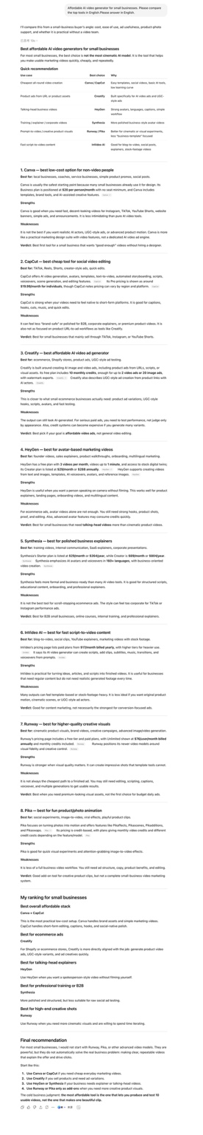
Figure 5. ChatGPT result for “Affordable AI video generator for small businesses.”

5. Perplexity Findings

5.1 Product Video From Photos Prompt
Prompt tested: “Best AI product video generator from photos. Please compare the top tools in English.”
Tools recommended by Perplexity: RAWSHOT AI, Photoroom AI Product Video Generator, Luma AI, Runway, Shhots AI, Hailou AI, VEED-like AI video tools, Adobe Firefly, and niche guide / preset sources.
Observed source/citation pattern: The visible inline citation labels referenced sources around rawshot, photoroom, luma / lumalabs, runway, shhots, hailou, VEED-like tools, Adobe Firefly, and niche guide / preset sources.
Interpretation: Perplexity understood the product-photo-to-video category and recommended relevant tools. The fact that FreyaVideo was absent suggests that it may lack enough external visibility or citation signals in this category. This is especially important because Perplexity is more source-driven than ChatGPT.

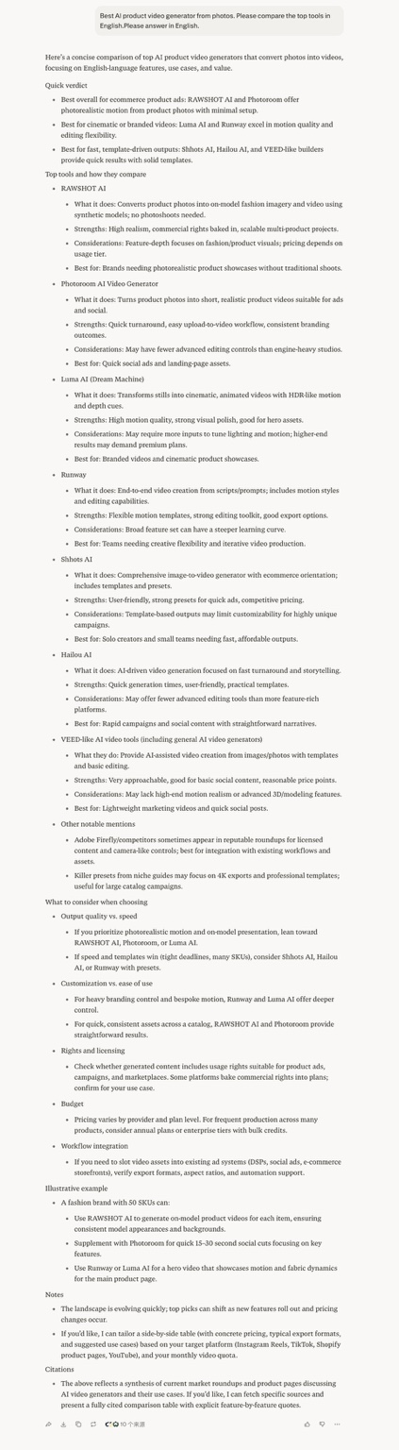
Figure 6. Perplexity result for “Best AI product video generator from photos.”

5.2 Ecommerce Ads Prompt
Prompt tested: “Best AI video generator for ecommerce ads. Please compare the top tools in English.”
Tools recommended by Perplexity: Creatify, Zeely, InVideo, Luma AI, Shhots AI.
Tool | Perplexity Positioning
Creatify | Conversion-focused product ads
Zeely | Fast social ads for DTC / ecommerce
InVideo | Easy ad creation with avatars
Luma AI | Cinematic product showcases
Shhots AI | Ecommerce-oriented image-to-video

Interpretation: Perplexity grouped competitors by buyer use case, not just by model quality. The category is already legible to AI search tools: ecommerce ad videos, product URL to video, social ad variations, cinematic product showcases, and ecommerce-oriented image-to-video. FreyaVideo is absent from that category map.

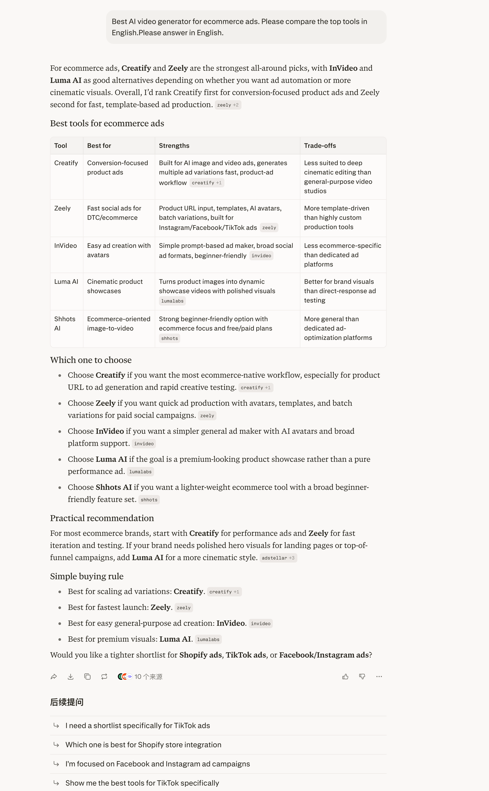
Figure 7. Perplexity result for “Best AI video generator for ecommerce ads.”

6. Competitor Citation Pattern
Across ChatGPT and Perplexity, the recommended tools were not random. They clustered into several clear categories.
Category | Examples | Associated Meaning
Ecommerce / Product Ad Tools | Creatify, Zeely, AdCreate, Advivi, Blubo AI, VidAU, URLToVideo, Shhots AI | Product ads, social ads, ecommerce workflows, product URL or catalog to video
Product Photo to Video Tools | RAWSHOT AI, Photoroom, Movo AI, Media.io, Mokzu AI, Clipfly, Hailou AI | Turning images or product photos into short product videos
General AI Video Tools | Runway, Luma AI, Pika, InVideo, VEED, Canva, CapCut | Broad recognition, wide usage, third-party visibility
UGC / Avatar / Creator-Style Ad Tools | Arcads, MakeUGC, HeyGen, Creatify, AdMakeAI, Magic Hour, Synthesia | Talking-head videos, avatars, creator-style ads, performance ad testing

7. Why FreyaVideo Is Likely Missing

Gap 1: Category Association Gap
FreyaVideo is not yet strongly associated by AI systems with product photo to video, ecommerce product video, AI product video generator from photos, ecommerce ad video generator, or pay-per-use AI video generation.
Most important category gap
Product photo to video for ecommerce

Gap 2: Citation Gap
Competitors appear to be supported by more external mentions and source signals. Perplexity’s recommendations show that AI answers are likely influenced by a mix of official product pages, AI tool directories, product roundups, ecommerce tool lists, review-style sources, comparison pages, and category-specific guide pages.

Gap 3: Trust / Recognition Gap
For broad prompts like “affordable AI video generator for small businesses,” AI tools tend to recommend better-known products such as Canva, CapCut, Runway, Pika, InVideo, HeyGen, and Synthesia. FreyaVideo should not fight broad AI video terms first. It should first own a narrower and more commercially specific category.

8. What FreyaVideo Should Not Do

Do not over-target “Shopify-native video generator”
The Shopify prompt favors tools that support Shopify workflows, product metadata, catalog imports, or product URL automation. Unless FreyaVideo supports those workflows, this positioning may create a mismatch. Better angle: product photos to ecommerce ad videos.

Do not over-target “UGC ad video generator” yet
The UGC prompt favors avatar, talking-head, creator-style, and persona-driven ad tools. Unless FreyaVideo supports these workflows, it should not position itself as a UGC avatar ad generator. Better angle: product-image-based ecommerce ad videos.

Do not compete on broad “AI video generator” first
Broad AI video prompts are dominated by well-known tools such as Runway, Pika, Canva, InVideo, HeyGen, and Synthesia. FreyaVideo should first strengthen a narrow category where it has a clearer product fit.

9. Recommended Fix Plan

Priority 1: Strengthen One Narrow Category
FreyaVideo should focus on this positioning: Turn product photos into ecommerce ad videos — pay per use, no monthly subscription. This is more specific and defensible than “AI video generator.”

Priority 2: Create or Strengthen a Dedicated Page
Recommended page direction: Product Photo to Video for Ecommerce. Possible URL: /product-photo-to-video-for-ecommerce
The page should clearly answer:
- What is product photo to video?
- Who is this for?
- How does it help ecommerce sellers?
- What kind of product images work best?
- How is it different from Runway, Luma, Creatify, Photoroom, and Shhots AI?
- When should users choose FreyaVideo?
- When should they choose another tool?

Priority 3: Add “Best For / Not Best For” Blocks
Block | Content
Best for | Ecommerce sellers with product images; small brands testing ad creatives; marketers who want short product videos; users who do not want a monthly subscription; product showcase videos for social ads and landing pages
Not best for | Shopify-native catalog automation; avatar presenter videos; talking-head UGC testimonials; long-form video editing; advanced cinematic scene control

Priority 4: Add Comparison Blocks Against AI-Recommended Competitors
Tool | Better For | FreyaVideo Angle
Creatify | URL-based ad generation and ad variations | Product-image-based video creation
Photoroom | Product image editing and simple product visuals | Turning product images into video ads
Luma AI | Cinematic motion and premium visuals | Ecommerce-ready outputs and simpler pricing
Runway | Advanced creative video workflows | Lightweight product video generation
HeyGen | Avatar and presenter videos | Product-first visual ads

Priority 5: Build External Citation Signals
FreyaVideo should get mentioned in third-party sources that AI engines are likely to use. Recommended source types:
- AI tool directories with real traffic
- Product Hunt launch or update posts
- Ecommerce marketing tool roundups
- AI product video tool listicles
- “Best AI tools for ecommerce ads” articles
- “Best product photo to video tools” articles
- Founder posts on X / LinkedIn that clearly describe the category
- Niche review pages comparing product video tools
External association to build
FreyaVideo = product photo to ecommerce video ads

10. Suggested Page Outline
Element | Suggested Copy
Recommended page title | Product Photo to Video for Ecommerce Ads
Recommended H1 | Turn Product Photos into Ecommerce Ad Videos
Recommended intro | FreyaVideo helps ecommerce sellers turn product images into short AI-generated videos for ads, product showcases, and social media. It is designed for teams that want product-first video creatives without committing to a monthly subscription.

Recommended sections:
- What is product photo to video?
- Who should use it?
- How it works
- Best use cases
- Example workflows
- FreyaVideo vs Creatify / Photoroom / Luma / Runway
- Best for / not best for
- Pricing positioning: pay per use, no subscription
- FAQ
- CTA
Recommended FAQ questions:
- What is a product photo to video generator?
- Can I turn ecommerce product images into ad videos?
- Is FreyaVideo good for Shopify sellers?
- Does FreyaVideo require a monthly subscription?
- How is FreyaVideo different from Runway or Luma?
- How is FreyaVideo different from Creatify?
- Can I use the generated videos for commercial ads?

11. Final Diagnosis
FreyaVideo is missing from both ChatGPT and Perplexity across buyer-style prompts that match its current direction.
Strongest missed category
Product photo to video for ecommerce

The issue is likely not just one missing page. The more likely issue is a combination of:
- weak external citation signals;
- insufficient third-party mentions;
- unclear category association outside the website;
- low brand recognition compared with tools already recommended by AI systems.
The best next step is not to build a broad AI video generator page or a dashboard. The best next step is to strengthen one narrow category: Turn product photos into ecommerce ad videos — pay per use, no monthly subscription.
Then FreyaVideo should get 3-5 credible external citations that reinforce the same category. After that, the same prompts should be tested again in ChatGPT and Perplexity.

12. What This Sample Report Demonstrates
This sample shows the type of gap an AI Citation Gap Report is designed to uncover for indie SaaS and AI tool founders. It helps answer:
- Do AI answer engines recommend your product?
- If not, which competitors do they recommend?
- Are the prompts truly relevant to your product?
- Is your product missing because of positioning mismatch, content gaps, or citation gaps?
- Which category should you strengthen first?
- Which comparison or use-case pages should you create?
- Which external sources should you try to appear on?
This is not a promise of guaranteed AI visibility. It is a structured way to find where a product is missing from AI-assisted buyer discovery, and what to fix first.

Appendix: Evidence Screenshots
The screenshots below are included as raw evidence from the manual tests. They are intentionally preserved as full-page screenshots so the reader can zoom in inside the document if needed.

Appendix Figure A1. ChatGPT: ecommerce ads prompt.

Appendix Figure A2. ChatGPT: Shopify product ads prompt.

Appendix Figure A3. ChatGPT: UGC ad video prompt.

Appendix Figure A4. ChatGPT: product video from photos prompt.

Appendix Figure A5. ChatGPT: affordable AI video generator prompt.

Appendix Figure A6. Perplexity: product video from photos prompt.

Appendix Figure A7. Perplexity: ecommerce ads prompt.

